Week 4 –2:
--Coding-C-Language Features-Optional.
ROLL NO.:240701198
Name: Jai Aakash S
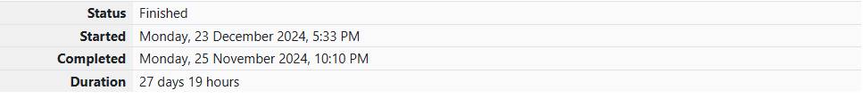
Q1)A set of N numbers (separated by one space) is passed as input to the program. The
program must identify the count of numbers where the number is odd number.
Input Format:
The first line will contain the N numbers separated by one space.
Boundary Conditions:
3 <= N <= 50
The value of the numbers can be from -99999999 to 99999999
Output Format:
The count of numbers where the numbers are odd numbers.
Sample Input:
5 10 15 20 25 30 35 40 45 50
Sample Output:
5
Code:
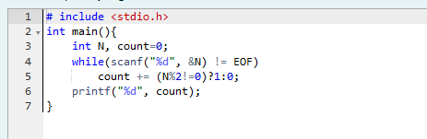

OUTPUT:
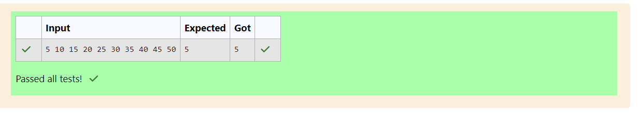

Q2)
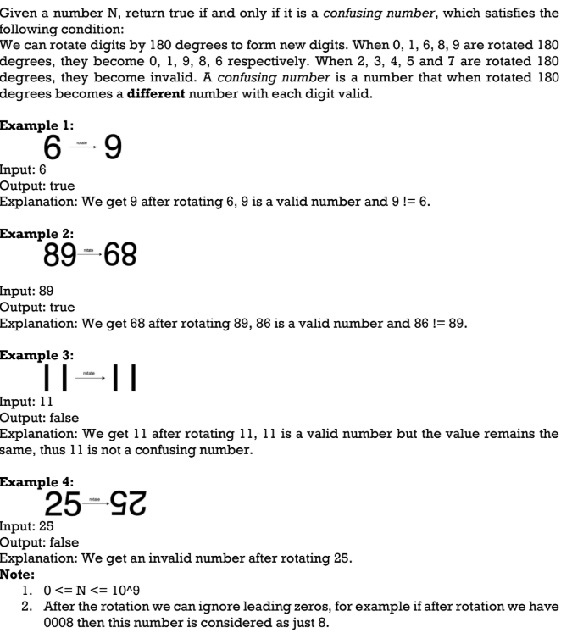

Code:
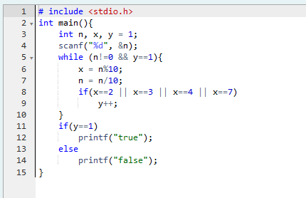

OUTPUT:
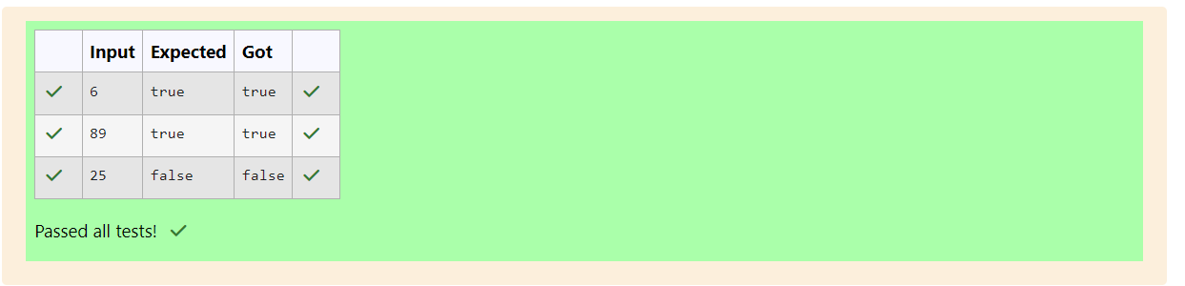

Q3)A nutritionist is labeling all the best power foods in the market. Every food item
arranged in a single line, will have a value beginning from 1 and increasing by 1 for each,
until all items have a value associated with them. An item's value is the same as the number
of macronutrients it has. For example, food item with value 1 has 1 macronutrient, food
item with value 2 has 2 macronutrients, and incrementing in this fashion.
The nutritionist has to recommend the best combination to patients, i.e. maximum
total of macronutrients. However, the nutritionist must avoid prescribing a particular sum
of macronutrients (an 'unhealthy' number), and this sum is known. The nutritionist chooses
food items in the increasing order of their value. Compute the highest total of
macronutrients that can be prescribed to a patient, without the sum matching the given
'unhealthy' number.
Here's an illustration: Given 4 food items (hence value: 1,2,3 and 4), and the
unhealthy sum being 6 macronutrients, on choosing items 1, 2, 3 -> the sum is 6, which
matches the 'unhealthy' sum. Hence, one of the three needs to be skipped. Thus, the best
combination is from among:
• 2 + 3 + 4 = 9
• 1 + 3 + 4 = 8
• 1 + 2 + 4 = 7
Since 2 + 3 + 4 = 9, allows for maximum number of macronutrients, 9 is the right
answer. Complete the code in the editor below. It must return an integer that represents
the maximum total of macronutrients, modulo 1000000007 (109 + 7).
It has the following:
n: an integer that denotes the number of food items
k: an integer that denotes the unhealthy number
Constraints
• 1 ≤ n ≤ 2 × 109
• 1 ≤ k ≤ 4 × 1015
Input Format For Custom Testing
The first line contains an integer, n, that denotes the number of food items. The second line
contains an integer, k, that denotes the unhealthy number.
Sample Input 0
2
2
Sample Output 0
3
Code:
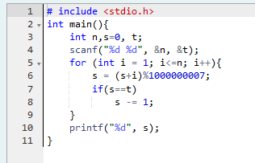

OUTPUT:
